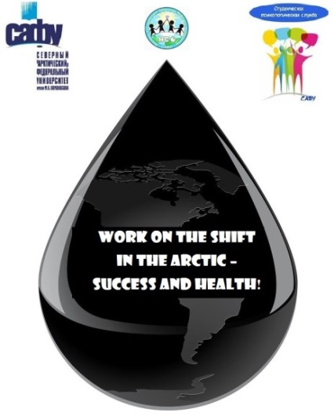

Northern (Arctic) Federal University
named after MV Lomonosov
Graduate School of Psychology, Pedagogy and Physical Education
Finnish Institute of Occupational Health
Arkhangelsk Branch of the Russian Psychological Society
Thematic network "Working in the Arctic" UArctic

IV Psychological Scientific and Practical School
"Work on the shift in the Arctic - success and health"

24-25 May 2019, Arkhangelsk

Northern Arctic Federal University (Arkhangelsk, North-West Russia) is pleased to announce the IV Psychological Scientific and Practical School "Work on the shift in the Arctic - success and health" to be held as a side event of the Arctic Science Summit Week (ASSW) 2019 that will take place at the university in 24-25 May, 2019.
The mission is a psychological and physiological readiness to effectively carry out future professional activities on a shift basis in the Arctic for students, while maintaining their health and well-being.
The goal is the development of psychological and practical competencies to increase the success of future professional activities on a rotational basis in the Arctic, as well as to overcome the adverse effects of the students' professional environment so that they can better adapt to the rotational organization of labor in the Arctic.
Tasks:
1. Development of competencies to address difficult and dangerous occupational situations in the workplace.
2. Self-assessment of their capabilities for the successful implementation of activities, the definition of their qualities that contribute to the successful implementation of activities.
3. Development of stress management skills and self-regulation skills.
4. Development of communication skills for teamwork, as well as an understanding of their place in the team and the importance of teamwork as a resource for overcoming the adverse effects of group isolation.
5. Development of competence in career planning and effective employment.

Participants:
- senior students in areas of oil and gas, geology and others who plan to work on a shift basis in the Arctic (20 people);
- young professionals with work experience of up to 3 years and under the age of 35 years working on a shift basis at oil and gas producing enterprises in the Arctic (5 people);
- senior students and undergraduates - psychologists who will provide psychological support for shift personnel in the Arctic (6 people)

Venue and dates
Arkhangelsk, Northern Arctic Federal University
24-25 May, 2019

Structure of the programme*
1. Business game "Competences of success for work in the Arctic"
2. Training "Development of stress tolerance and self-regulation"
3. Master class "Family in a professional career"
*The organizers reserve the right to make changes in the programme structure with regard to the Forum schedule.

Workload
1 ECTS. Certificates and transcripts of records are provided for participants

Language of instruction
English

Financing
Participation fee is not provided.
Travel and accommodation is due to the directing side.

Travel
Arrival day: 24 May 2019
Departure day: 25 May 2019
Important Dates
28 January 2019 – Deadline Accepting applications for participation as a lecturer and master class
18 February 2019 - Deadline Call for applications of senior students or young professionals
11 March 2019 - Confirmation of school participants

Organizers and trainers / lecturers:
Natalya Simonova – Doctor of Psychology, Professor, Leading Researcher of the Laboratory of Labor Psychology, Faculty of Psychology, Moscow State University named after M.V. Lomonosov
Yana Korneeva – Candidate of Psychological Sciences, Associate Professor, Head of the Psychology Department at NArFU named after M.V. Lomonosov
Sirkka Rissanen – Specialist Research Scientist, PhD, Finnish Institute of Occupational Health

To participate, you must fill out an application and send it along with your CV and motivation letter of by email psps_wsash@bk.ru until 28 January 2019 (for lecturer and master class) and until 18 February 2019 (senior students or young professionals)

Application for participation as a lecturer and master class:
Application for participation of senior students or young professionals:

Should you have any questions, please do not hesitate to contact of by email psps_wsash@bk.ru.

Share your passion for the Arctic!

