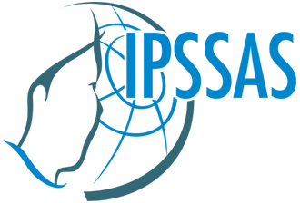

MODERNIZATION AND HERITAGE
- HOW TO COMBINE THE TWO IN INUIT SOCIETIES?
8th Seminar of the International PhD School for Studies of Arctic Societies (IPSSAS)
at Kangerlussuaq and Ilisimatusarfik (University of Greenland),
May 20 (arrival) to May 30 (departure) 2011.

Hosted by Ilisimatusarfik, the University of Greenland

Theme Description
Like other societies, Inuit societies have in past and present times had to deal with the trade-off between radical social and cultural change and the preservation of cherished cultural and social customs and traditions. In modern terms, this trade-off is referred to as the trade-off between modernization and preservation of heritage. Happily, the choice of the one alternative does not necessarily imply a full rejection of the other. Like individuals, societies can change profoundly without abandoning essential elements of their former life and opinions.
This seminar seeks to illuminate the ways in which Inuit societies in past and present times have endeavoured to make both ends meet
• In the field of language
• In the field of economy
• In the field of cultural and social habits and attitudes
• In the field of literature and mass media
as well as in many other fields …
IPSSAS 2011 will be a unique opportunity to discuss issues and present current research on how past and present Inuit societies across the Circumpolar North have coped with the trade-off between modernization and heritage. Our goal is to cultivate substantive discussions and exchange of the highest scholarly standard in the social sciences, arts and humanities.
The first part of the seminar will take place in Kangerlussuaq near the Ice Cap/Inland Ice. Apart from being home to one of Greenland’s international airports, Kangerlussuaq also is home to a natural park. The main part of the seminar takes place at Ilisimatusarfik, the University in Greenland, which is situated in Greenland’s capital Nuuk.
Eligibility:
We invite graduate students working on arctic issues, based in university institutions worldwide, to participate in this session. PhD students will be given priority.
Course Credit Equivalent:
3 North American credits or equivalent in European institutions.
Application:
Information about applications is available at the IPSSAS website:
http://webarkiv.hum.ku.dk/ipssas/applicationnuuk2011/html

